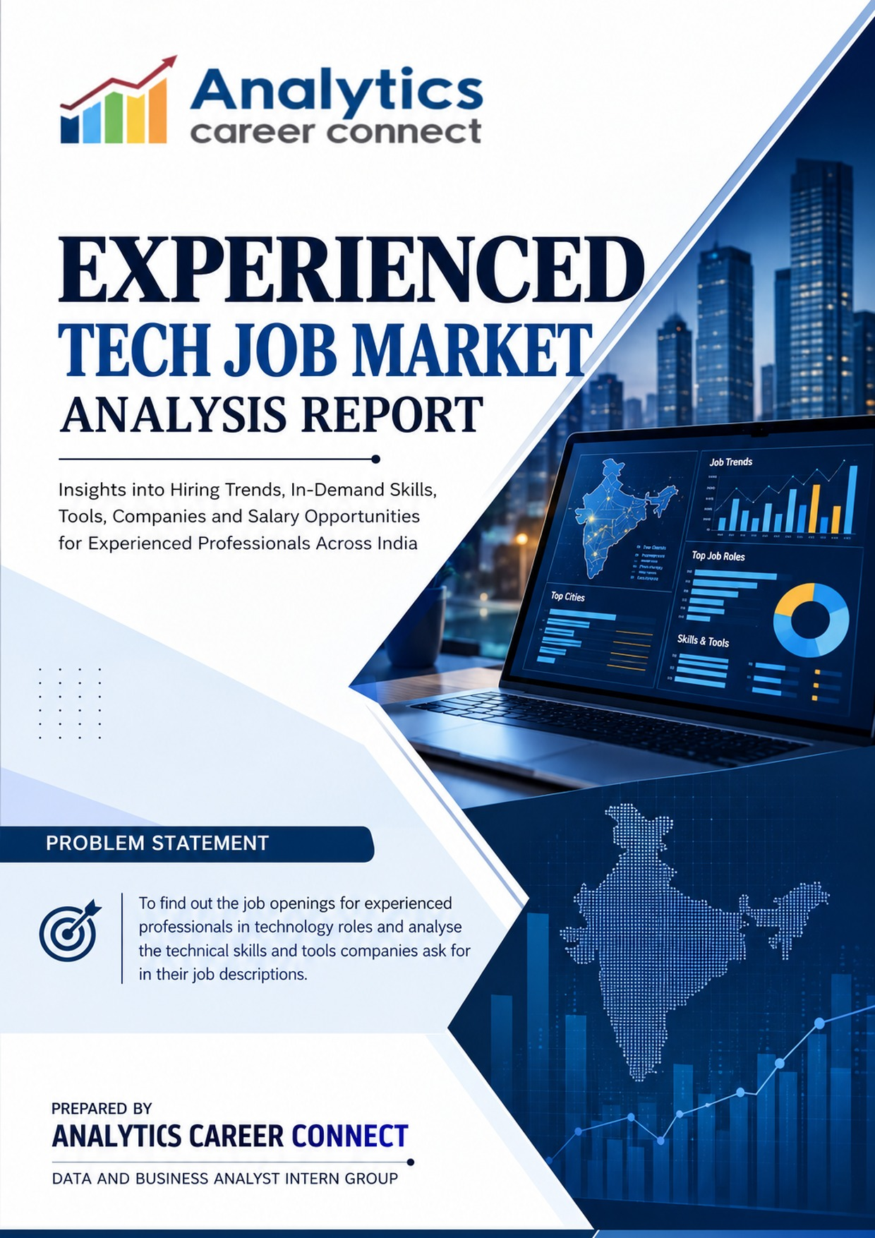

Table of Contents

Section | Contents | Page
1 | Executive Summary | 3
2 | Introduction | 4
2.1 | Importance of Experienced Tech Job Market Analysis | 4
2.2 | Objectives of the Dashboard | 4
2.3 | Scope of Analysis | 5
2.4 | Data Sources & Methodology | 5
2.5 | Why the Dashboard Was Developed | 5
2.6 | Key Business Questions It Answers | 5
3 | Dashboard Overview | 6
3.1 | Dashboard Objectives | 6
3.2 | Dashboard Components | 6
4 | Tech Job Market Overview Analysis | 7
4.1 | Overall Experienced Tech Job Market | 7
4.2 | City-wise Hiring Analysis | 7
4.3 | State-wise Hiring Analysis | 8
4.4 | Department Analysis | 8
4.5 | Job Role Analysis | 9
4.6 | Work Mode Analysis | 9
4.7 | Experience Distribution | 10
5 | Skills & Career Analysis | 11
5.1 | Skills by Department and Job Role | 11
5.2 | Technical and Soft Skills by Company | 12
5.3 | Technical Skills by Experience | 12
5.4 | Tools Analysis and Dashboard Limitations | 12
5.5 | Education and Skills Coverage | 12
5.6 | Experience Requirement Analysis | 12
6 | Salary Analysis | 14
6.1 | Salary Overview | 14
6.2 | Salary Range Distribution | 14
6.3 | Salary by Experience | 15
6.4 | Salary by Work Mode | 15
6.5 | Highest-Paying Roles as Displayed | 15
6.6 | Salary by Education and Department | 15
7 | Key Business & Career Insights | 16
8 | Recommendations | 17
8.1 | For Experienced Professionals | 17
8.2 | For Training Institutions | 17
8.3 | For Analytics Career Connect | 18
9 | Conclusion | 18
Appendix | Data Notes & Caveats | 19

1. Executive Summary
The Experienced Tech Job Market Analysis Report examines technology job postings for experienced professionals in India. The supplied Power BI dashboard records 11,707 jobs from 5,532 hiring companies, with 5,631 distinct job-role labels across 300 cities and 18 states. It brings together role demand, location, department, experience range, work mode, skill-entry counts and salary-related visuals to support career planning and dashboard improvement.
Dashboard indicator | Reported value
Total jobs | 11,707
Companies hiring | 5,532
Distinct job-role labels | 5,631
Hiring cities | 300
Hiring states | 18
Most frequent listed role | Data Engineer — 811 jobs
Most common work mode | Remote — 48.59%
Largest experience ranges | 5–10 years — 810; 2–5 years — 789

Key Findings
- Data-focused roles lead the named role list. Data Engineer (811), Data Scientist (556) and Data Analyst (446) are the three largest listed titles. Senior Data Engineer (244) and Azure Data Engineer (158) add to a strong data-engineering segment.
- Department-tagged demand is concentrated in Software Development and data-related areas. Software Development has approximately 3.79K jobs, Data Engineering 3.06K, AI/ML 1.91K, Data Science 1.46K and Data Analytics 0.99K.
- The largest experience labels are 5–10 years (810 jobs) and 2–5 years (789). The labels overlap and should be treated as employer wording, not as mutually exclusive statistical bands.
- Remote and hybrid opportunities dominate the dashboard’s work-mode split: remote 48.59%, hybrid 33.91% and on-site 17.50%. Together, remote and hybrid account for 82.5% of the displayed split.
- Hiring is distributed across many employers. Accenture has 206 jobs, Diverse Lynx 184 and Coders Brain Pvt Ltd 144. The top ten listed companies account for about 1,063 jobs, roughly 9% of all jobs.
- Salary results should not be used as reliable market benchmarks yet. The salary visuals mix labels and units, and source-platform counts suggest that salary-related figures may be based on a small subset of records.

Overall Interpretation
The dashboard points to substantial demand for data engineering, data science, analytics and software development skills among experienced technology professionals. It also indicates that flexible work modes are common in the captured listings. However, role-name fragmentation, missing locations, overlapping experience labels and inconsistent salary visuals limit precision. Career decisions should therefore use the role and work-mode patterns as directional signals, while salary comparisons remain provisional until the underlying model is validated.

2. Introduction

2.1 Importance of Experienced Tech Job Market Analysis
Experienced technology professionals often need to evaluate career moves by role specialisation, seniority, work arrangement, geography and the tools employers request. A structured job-market analysis helps distinguish broad demand patterns from individual job advertisements and can guide skill refreshers, portfolio choices and job-search targeting.
For professionals already in the workforce, the question is not only which roles are available, but which role families have repeated demand, which locations show meaningful hiring activity, how experience is described by employers, and whether opportunities are remote, hybrid or on-site. A dashboard can help organise these dimensions, provided its categories and measures are interpreted carefully.

2.2 Objectives of the Dashboard
- Measure experienced technology hiring volume across roles, companies, cities and states.
- Identify job titles and departments with the largest visible posting counts.
- Review the distribution of experience labels and work modes.
- Examine the skill-entry information available by department, role, company and experience range.
- Summarise hiring-company concentration and job-source platform coverage.
- Review the available salary visuals while identifying unit, coverage and categorisation limitations.
- Translate the observed patterns into practical guidance for professionals, training institutions and Analytics Career Connect.

2.3 Scope of Analysis
The report uses the experienced-job Power BI dashboard supplied with the project. Its scope includes 11,707 jobs, 5,532 hiring companies, 5,631 distinct role labels, 300 cities and 18 reported states. The dashboard has three pages: Overview; Skills & Tools Required; and Companies and Pay. The report analyses the visible indicators and chart values from these pages. It does not infer unavailable role-specific tool frequencies or industry rankings.

2.4 Data Sources & Methodology
Primary source: Experienced_Job_Analysis.pdf, a three-page export of the Power BI dashboard. The companion Experienced Tech Job Market report and its embedded charts were used to retain the values and caveats already associated with the dashboard. Analysis is descriptive: displayed counts and percentages are summarised, comparisons are calculated only where the source values support them, and estimated chart values are explicitly identified as estimates.
Where a chart does not label a value directly, this report retains the estimate documented in the supplied analysis rather than presenting it as an exact figure. The salary section is deliberately cautious because the dashboard combines values labelled as LPA with others labelled in thousands (K), without a clear unit conversion or adequate salary-record coverage.

2.5 Why the Dashboard Was Developed
The dashboard provides a consolidated view of experienced technology hiring so that users can identify role families with visible demand, compare geographic and work-mode patterns, understand the experience wording used in postings, and inspect the available skills and pay indicators. It also exposes data-quality issues that should be addressed before the dashboard is used for precise benchmarking.

2.6 Key Business Questions It Answers
- How many experienced technology jobs and hiring companies are represented?
- Which named job roles and departments appear most frequently?
- Which cities and states show the strongest visible hiring activity?
- What work modes and experience ranges are most common in the dashboard?
- How are technical and soft-skill entries distributed across selected companies and experience ranges?
- Which companies appear most frequently among the displayed top employers?
- What salary patterns are shown, and what limitations prevent reliable benchmarking?

3. Dashboard Overview

3.1 Dashboard Objectives
The dashboard is designed to give users a quick overview of experienced technology hiring, followed by more focused views of skills and company/pay information. The Overview page prioritises total jobs, employers, role labels, locations, departments, experience and work mode. The Skills & Tools page groups skill-entry counts by department and job role, company and experience range. The Companies and Pay page lists leading employers and presents salary-related visuals.

3.2 Dashboard Components
Dashboard page | Visible components | Interpretation
Overview | KPI cards; jobs by experience range; top hiring cities; top job roles; top departments; top hiring states; preferred work mode. | Best for understanding market scale, role demand, location and work arrangement.
Skills & Tools Required | Skills by department and job; technical vs soft-skill entries by company; department-share visual; technical-skill entries by experience. | Shows how skill information is represented, but does not provide a ranked list of individual technologies or tools.
Companies and Pay | Average-salary KPI; salary by education; top hiring companies; salary by job; source platforms; salary by experience; salary by department. | Useful as a layout for further analysis, but salary measures and department categories require validation before interpretation.

How to Read the Dashboard
Counts in the dashboard represent jobs or skill entries according to each visual’s measure; these are not always interchangeable. For example, the technical-skill count by experience is close to the number of jobs in the same experience label, but it should not be read as the count of unique skills. Similarly, the department visual and salary donut use labels that differ from the Overview page, so their categories need validation before the percentages are compared.

4. Tech Job Market Overview Analysis

4.1 Overall Experienced Tech Job Market
The dashboard captures 11,707 jobs from 5,532 companies. It reports 5,631 distinct role labels, which is unusually high relative to the job count and signals that titles are highly fragmented. Differences in seniority wording, technology stacks, spelling and role naming may cause similar jobs to be counted separately. Standardising titles into role families would make the market easier to compare.
The average is approximately 2.1 jobs per company (11,707 divided by 5,532). This simple ratio is consistent with a fragmented market in which many employers contribute relatively small numbers of listings. It does not mean that each company has the same hiring volume.

4.2 City-wise Hiring Analysis
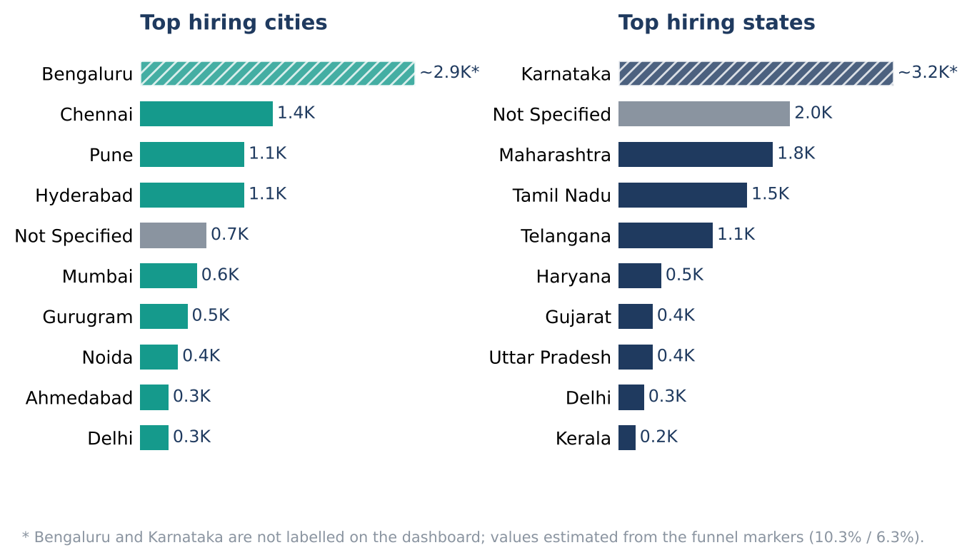
Figure 1. Top hiring cities and states; Bengaluru value is estimated from the funnel marker.
Bengaluru is the largest city in the displayed funnel, estimated at approximately 2.9K jobs because the dashboard does not print a direct value label. Chennai follows at about 1.4K, while Pune and Hyderabad each show about 1.1K. Mumbai is approximately 0.6K and Gurugram about 0.5K. Around 0.7K jobs are categorised as “Not Specified” for city.
The city pattern suggests that experienced hiring is not limited to Bengaluru. Chennai, Pune and Hyderabad each represent meaningful markets in the dashboard. The missing-city category is also large enough to affect geographic comparisons and should be resolved before location-specific totals are used for planning.

4.3 State-wise Hiring Analysis
Karnataka leads the displayed state funnel at an estimated 3.2K jobs, followed by “Not Specified” at about 2.0K, Maharashtra at 1.8K, Tamil Nadu at 1.5K and Telangana at 1.1K. Karnataka’s figure is estimated because it is not directly labelled in the chart. Approximately 2.0K jobs have no state specified, about 17% of all jobs.
The missing-state total is substantial. It may represent incomplete extraction, inconsistent location strings or postings for which the state was not included. Since the dashboard reports 18 hiring states, the state KPI should be checked to determine whether “Not Specified” is included in the count.

4.4 Department Analysis
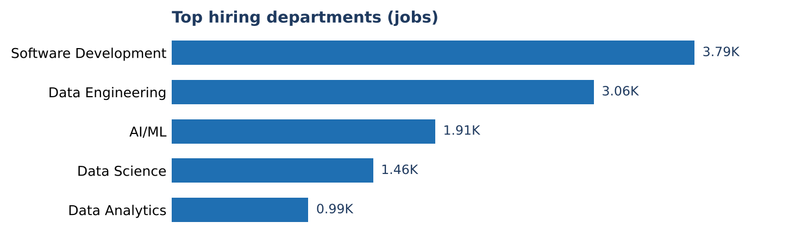
Figure 2. Top hiring departments by job count.
Software Development leads with approximately 3.79K jobs, followed by Data Engineering at 3.06K, AI/ML at 1.91K, Data Science at 1.46K and Data Analytics at 0.99K. The four data-oriented categories—Data Engineering, AI/ML, Data Science and Data Analytics—sum to about 7.42K jobs, approximately 63% of the full 11,707-job total or around 66% of department-tagged jobs, depending on the denominator used.
This supports the view that data-related capabilities form a major portion of the represented experienced market. The dashboard’s department values are rounded, so combined totals and percentages should also be treated as approximate.

4. Tech Job Market Overview Analysis (continued)

4.5 Job Role Analysis
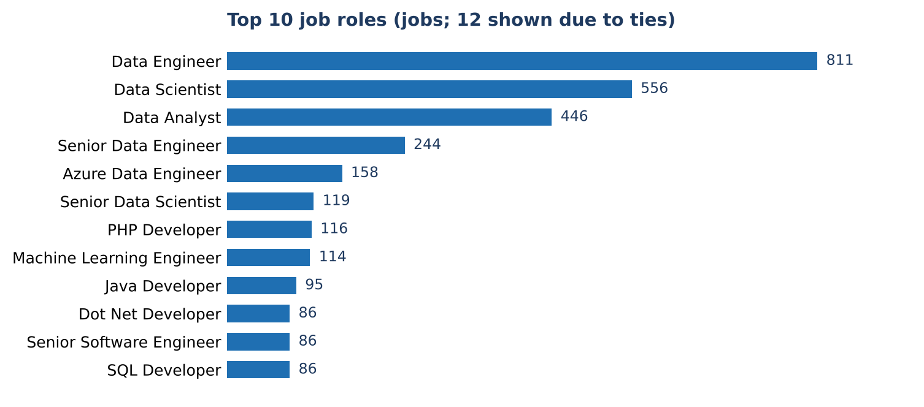
Figure 3. Top job roles by number of jobs; 12 titles are shown because of ties at 86.
Data Engineer leads the displayed role list with 811 jobs. Data Scientist has 556, Data Analyst 446 and Senior Data Engineer 244. Azure Data Engineer has 158, Senior Data Scientist 119 and Machine Learning Engineer 114. Other visible roles include PHP Developer (116), Java Developer (95), Dot Net Developer (86), Senior Software Engineer (86) and SQL Developer (86).
The three named data-engineering titles—Data Engineer, Senior Data Engineer and Azure Data Engineer—sum to 1,213 jobs, about 10.4% of the market. The twelve displayed titles account for approximately 2.9K jobs, around one-quarter of the total. The remaining demand is distributed across thousands of other titles, reinforcing the need for role-family standardisation.

4.6 Work Mode Analysis
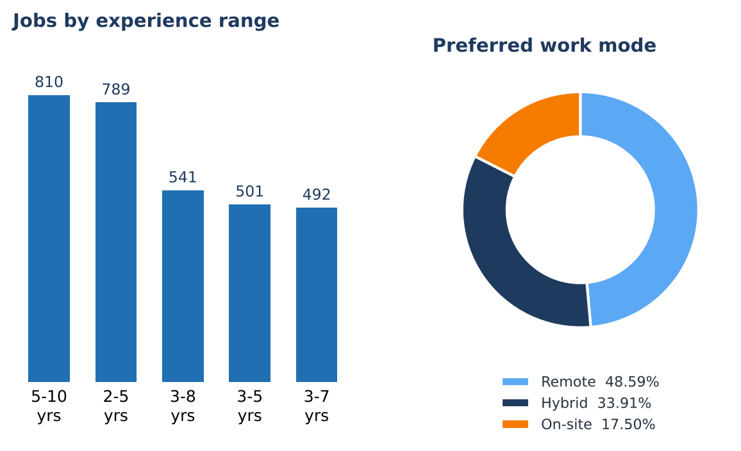
Figure 4. Jobs by experience range and preferred work mode.
Remote is the largest work-mode category at 48.59%, followed by hybrid at 33.91% and on-site at 17.50%. Applied to all 11,707 jobs, these percentages correspond roughly to 5.7K remote, 4.0K hybrid and 2.0K on-site listings, though the chart’s percentages should be treated as its own split. Remote and hybrid together account for 82.5% of the displayed distribution.
This is a useful directional signal for experienced professionals who prefer flexible arrangements. It should not be interpreted as a guarantee that a specific role or employer supports remote work; the actual listing and employment conditions should always be checked.

4.7 Experience Distribution
The five largest displayed experience labels are 5–10 years (810 jobs), 2–5 years (789), 3–8 years (541), 3–5 years (501) and 3–7 years (492). Together they represent about 3.1K jobs. These ranges overlap by design: for example, a candidate with four years of experience falls within several of the listed ranges. They therefore reflect employer wording rather than mutually exclusive experience bands.
The data suggests a meaningful number of listings aimed at professionals with a few years of experience and at mid-career candidates. However, the dashboard does not provide a clean, non-overlapping experience distribution. The counts should not be summed to estimate the full market share of a particular seniority level.

5. Skills & Career Analysis
The Skills & Tools Required dashboard page differs from the fresher dashboard. It does not provide a ranked list of individual technical skills and software tools. Instead, it displays skill-entry counts by job/department, company and experience range. The following analysis stays within those available measures and does not infer individual technology demand that the dashboard does not show.

5.1 Skills by Department and Job Role
The role/department visual highlights a substantial data-engineering cluster. Data Engineer (811), Senior Data Engineer (244) and Azure Data Engineer (158) total 1,213 jobs across three displayed titles. Data Science includes Data Scientist (556) and Senior Data Scientist (119), totalling 675. Data Analytics is represented by Data Analyst with 446 jobs. Software Development roles shown include PHP Developer (116), Java Developer (95), Dot Net Developer (86), Senior Software Engineer (86) and SQL Developer (86).
These values show which role families appear most frequently; they do not identify the exact tools required within each role. To answer the original project question about tools requested in job descriptions, the underlying skill/tool fields should be normalised and visualised as a separate ranked list for the experienced dataset.

5.2 Technical and Soft Skills by Company
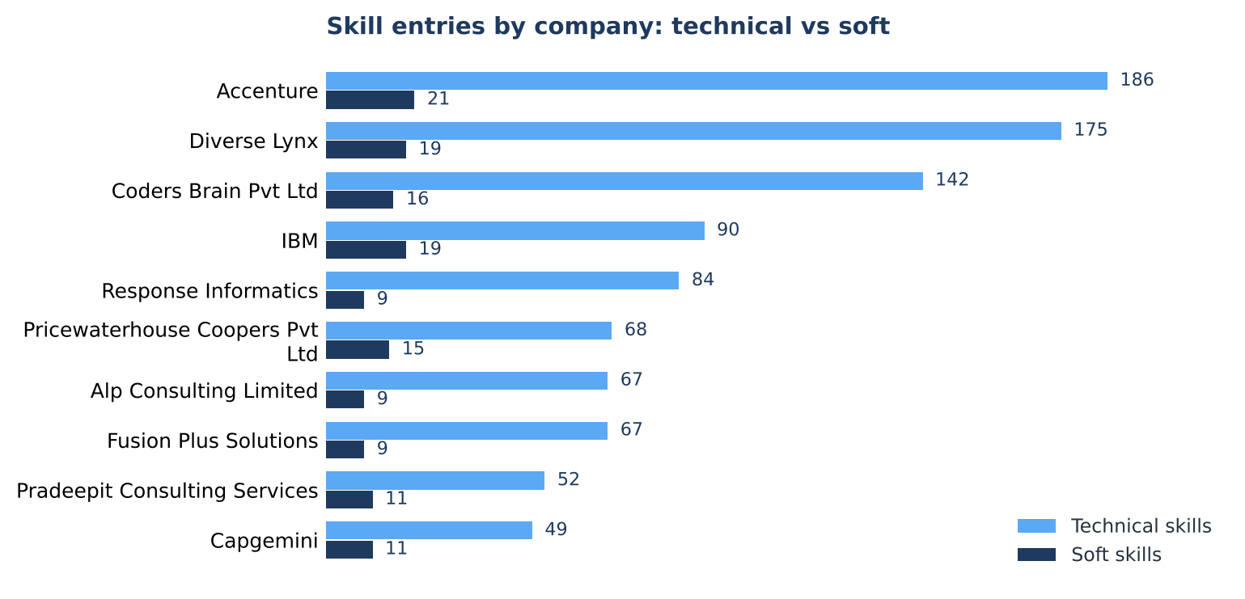
Figure 5. Technical and soft-skill entries for the ten largest companies shown in the Skills page.
Across the ten companies shown, the dashboard reports 980 technical-skill entries and 139 soft-skill entries—about seven technical entries for every soft-skill entry. Accenture has 186 technical and 21 soft entries; Diverse Lynx has 175 and 19; Coders Brain Pvt Ltd has 142 and 16. IBM has 90 and 19. Other displayed companies include Response Informatics, PricewaterhouseCoopers Private Limited, Alp Consulting Limited, Fusion Plus Solutions, Pradeepit Consulting Services and Capgemini.
The comparison suggests that the dashboard’s extracted descriptions capture more technical-skill entries than soft-skill entries for these employers. However, these are entry counts rather than percentages of job postings or proof that soft skills are unimportant. Differences in extraction and description length can affect the ratio.

5.3 Technical Skills by Experience
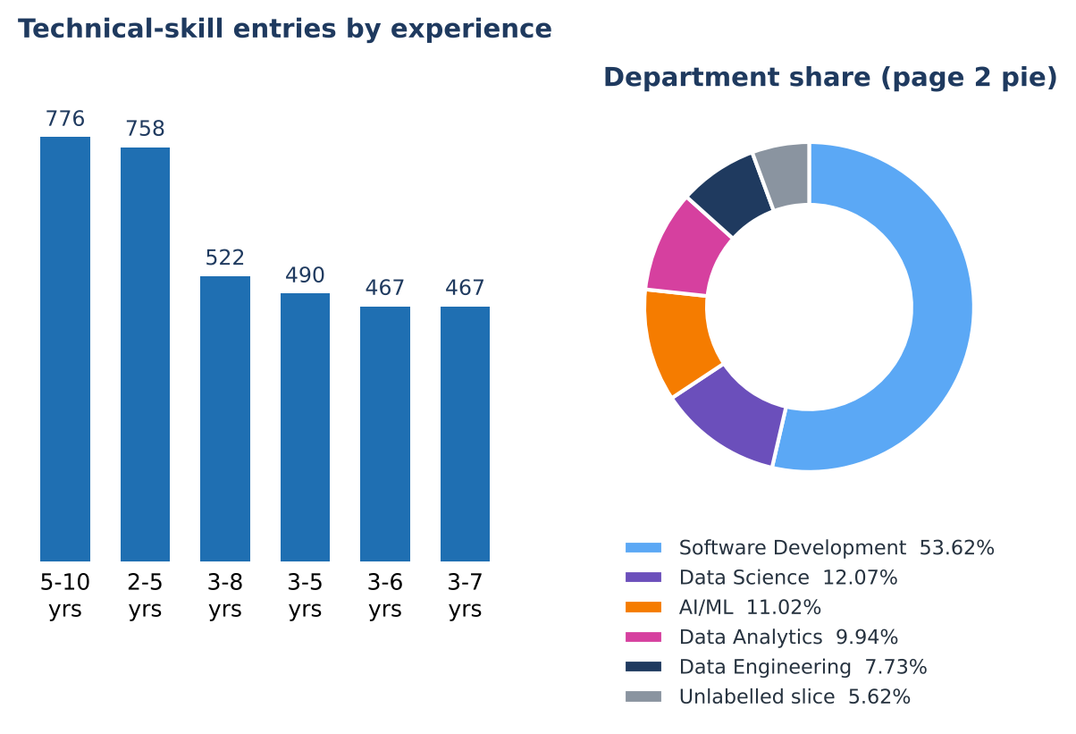
Figure 6. Technical-skill entry counts by experience label; department-share donut is also shown in the source visual.
Technical-skill entry counts are 776 for the 5–10 years label, 758 for 2–5 years, 522 for 3–8 years, 490 for 3–5 years and 467 for each of 3–6 and 3–7 years. These values are close to the job counts shown for corresponding labels, suggesting skill information is populated for many records in these categories. Because experience labels overlap, this comparison should be used to review coverage rather than to sum skill demand across seniority groups.

5.4 Tools Analysis and Dashboard Limitations
The experienced dashboard does not show a dedicated ranked chart for individual tools such as SQL platforms, cloud services, programming languages or development environments. Consequently, this report cannot responsibly claim that a specific tool is the most requested based on this dashboard alone. The project’s stated objective would be better served by adding a tool-frequency chart derived from the raw job-description fields, with duplicate names normalised and each posting counted consistently.

5.5 Education and Skills Coverage
The Companies and Pay page includes salary by education, but the categories are combined strings such as “Master’s”, “Bachelor’s, Master’s”, “Not Specified” and other mixed degree labels. This visual does not provide a clean education distribution and should not be used to infer the qualification most commonly required by experienced technology employers.
For a more reliable education analysis, degree names should be parsed into standard categories (for example, bachelor’s, master’s, diploma, doctorate and not specified) while preserving combined values where a posting explicitly lists multiple acceptable qualifications. Education analysis should be separated from salary analysis so that the count of job postings by qualification can be distinguished from average salary among records that contain pay data.

5.6 Experience Requirement Analysis
The experience-range chart shows the greatest counts in the 5–10 years and 2–5 years labels, with additional volume in overlapping 3–5, 3–7 and 3–8 years labels. These are useful search phrases for identifying mid-career opportunities, but the categories need re-bucketing before the dashboard can report exact market shares by experience level.
A recommended structure is to derive one mutually exclusive band per posting, such as 0–1, 2–3, 4–5, 6–8, 9–10 and 10+ years, using the lower and upper bounds extracted from each job description. Where a range cannot be parsed, it should be stored as “Unclear/Not specified” rather than assigned to multiple bands.

Career Interpretation
- Professionals focused on data engineering can prioritise Data Engineer, Senior Data Engineer and Azure Data Engineer searches because these are prominent role titles in the dashboard.
- Data science and analytics professionals can review Data Scientist, Senior Data Scientist and Data Analyst postings, then inspect each description for the exact stack and seniority expectations.
- Software developers should not ignore software-role titles that appear below the top data roles; the displayed list is only a small slice of the 5,631 distinct role labels.
- Use the experience range in each job advertisement rather than relying only on the dashboard’s overlapping category labels.

6. Salary Analysis
The salary section must be treated as provisional. The dashboard’s salary page contains inconsistent units and categories, and its source-platform chart totals only 60 records (Naukri public dataset 52, Glassdoor 8 and LinkedIn 0) against 11,707 jobs. This suggests that salary-related measures may rely on a small subset or that some visuals use measures not aligned with the dashboard labels. Figures below are reported as displayed, not endorsed as valid salary benchmarks.

6.1 Salary Overview
The headline salary KPI displays “52” with the label “Average Salary (LPA)”. The same value appears to match the Naukri public-dataset count and the number in the department donut, so it may be a record count rather than an average salary. The dashboard should be corrected to show a clearly defined average salary, the currency and period, and the number of postings with valid salary values.

6.2 Salary Range Distribution
The dashboard does not provide a clear salary-range distribution that can be interpreted confidently. A reliable salary analysis would group valid annual salary values into consistent ranges, distinguish disclosed from undisclosed salary, and exclude or separately flag values that cannot be converted into the chosen currency and period. No market-share claim by salary band is made in this report because the source does not support it.

6.3 Salary by Experience
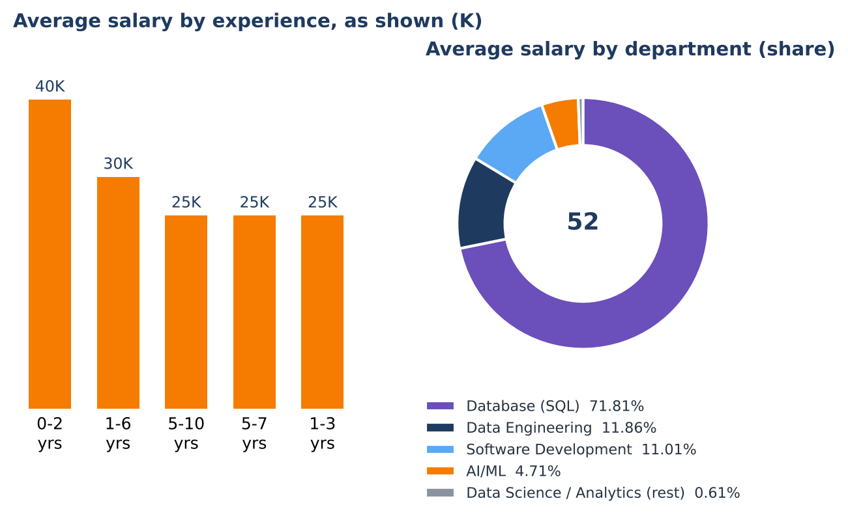
Figure 7. Salary by experience (values labelled K) and department share as shown in the dashboard.
The experience chart shows 0–2 years at 40K, 1–6 years at 30K, and 5–10, 5–7 and 1–3 years at 25K each. The chart labels these values in “K” but does not state whether they represent monthly rupees, annual salary or another unit. They must not be compared directly with values labelled LPA elsewhere on the same dashboard.

6.4 Salary by Work Mode
A salary-by-work-mode comparison is not provided in the supplied experienced dashboard. The report therefore does not claim that remote, hybrid or on-site jobs pay more than one another. If this comparison is added, it should use salary records with standardised units and show sample counts for each work mode so that small groups are not mistaken for stable market differences.

6.5 Highest-Paying Roles as Displayed
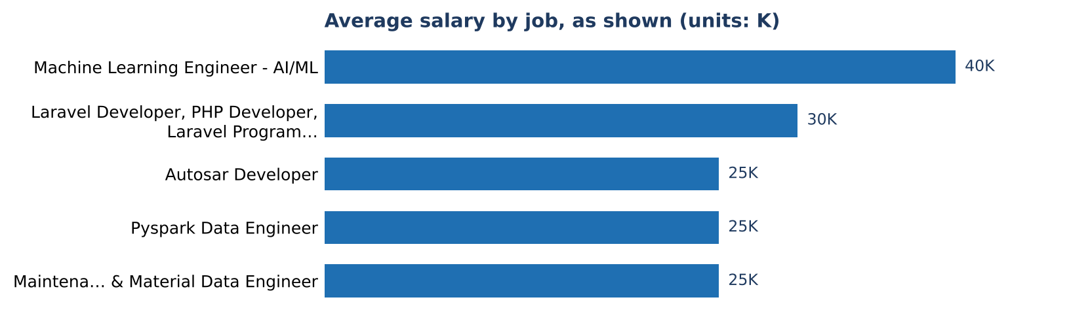
Figure 8. Average salary by job as displayed; the chart labels values in K.
The role chart shows Machine Learning Engineer – AI/ML at 40K. A combined Laravel/PHP-related group appears at 30K, followed by Autosar Developer, Pyspark Data Engineer and a Maintenance & Material Data Engineer role at 25K each. Some labels combine multiple titles or are truncated, and the unit is not reconciled with the LPA label used elsewhere. These values should be treated as a dashboard quality signal rather than a defensible ranking of highest-paying roles.

6.6 Salary by Education and Department
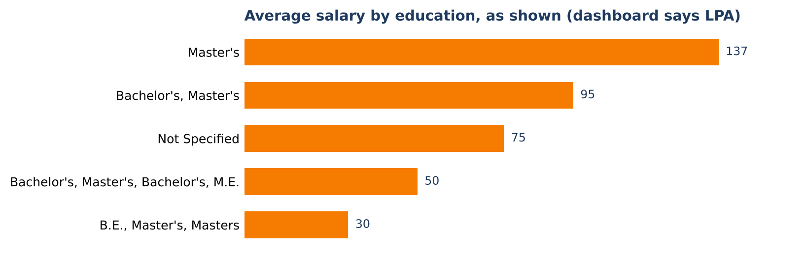
Figure 9. Salary by education as shown in the dashboard; units and category groupings require validation.
The education visual displays Master’s at 137, Bachelor’s/Master’s at 95, Not Specified at 75, a combined Bachelor’s/Master’s/Bachelor’s/M.E. category at 50, and a B.E./Master’s/Masters combination at 30. These values are inconsistent with the “Average Salary (LPA)” label and may represent an incorrectly aggregated measure. They should not be interpreted as actual LPA values until the measure and data type are checked.
The department donut is dominated by Database (SQL) at 71.81%, followed by Data Engineering at 11.86%, Software Development at approximately 11.0%, AI/ML at 4.71% and Data Science/Analytics at a small share. “Database (SQL)” does not appear as a department in the Overview chart, indicating inconsistent category mapping. The donut’s centre value “52” also appears inconsistent with a department share chart.

Salary Data: Required Validation
- Confirm whether the salary KPI is a count, mean, median or another measure.
- Standardise all salaries to a single currency and period, such as annual INR in LPA.
- Track the number of jobs with salary values and show it beside every salary visual.
- Separate monthly salary, annual salary, salary ranges and non-numeric text before aggregation.
- Normalise job titles and education labels so that one chart category does not combine unrelated roles or degrees.
- Rebuild the department salary visual using the same department taxonomy as the Overview page.

7. Key Business & Career Insights

7.1 Data Engineering Is a Visible Opportunity Cluster
Data Engineer is the leading named title at 811 jobs, with Senior Data Engineer and Azure Data Engineer adding another 402. This makes data engineering a useful focus area for experienced professionals whose background matches pipeline development, data platforms, cloud services or related work. The dashboard does not list the individual tools required in each posting, so applicants should validate those requirements directly from job descriptions.

7.2 Data Roles Represent a Major Share of Department Demand
Data Engineering, AI/ML, Data Science and Data Analytics together account for approximately 7.42K jobs across the displayed department values. The combined total indicates that data-related work is prominent in this dataset, while Software Development remains the largest single department.

7.3 Flexible Work Modes Are Common
The displayed split gives remote 48.59% and hybrid 33.91%, for a combined 82.5%. Experienced professionals can include remote and hybrid filters in their search strategy, while confirming location eligibility, time-zone expectations and attendance policies in individual postings.

7.4 Location Choice Can Extend Beyond Bengaluru
Bengaluru leads the city funnel, but Chennai, Pune and Hyderabad each show around 1.1K–1.4K jobs. Professionals can broaden their search to these locations rather than relying on one city. Missing city and state values are significant, so location comparisons should be revisited after data cleaning.

7.5 Hiring Is Spread Across Many Employers
The top ten employers account for roughly 9% of jobs. The visible list includes large companies as well as consulting and staffing-oriented organisations. Professionals should consider both direct employers and firms recruiting for client projects, and should verify the end client, employment type and project duration when relevant.

7.6 Salary Insights Are Not Yet Decision-Grade
The salary dashboard’s mixed units, ambiguous KPI and limited source-platform count make salary comparisons unreliable. The role and location counts can be used directionally, but salary negotiation or career decisions should rely on verified job offers, clear salary disclosures and corrected dashboard measures—not the current salary charts.

7.7 Role and Experience Taxonomy Needs Improvement
The 5,631 role labels and overlapping experience ranges reduce comparability. Standardising titles into role families and assigning one experience band per posting would make the dashboard more useful for both job seekers and training teams.

8. Recommendations

8.1 For Experienced Professionals
- Prioritise role families that match proven experience. Data Engineer, Senior Data Engineer, Azure Data Engineer, Data Scientist and Data Analyst are prominent in the displayed role list.
- Search across multiple locations. Include Bengaluru, Chennai, Pune and Hyderabad, and do not automatically exclude remote or hybrid roles.
- Read the full job description before selecting a learning path. The current experienced dashboard does not rank individual tools, so specific technologies should be taken from each relevant listing.
- Translate experience into evidence. Update the résumé with measurable outcomes such as pipeline reliability, data quality, system performance, deployment frequency, analytics adoption or business impact, where applicable.
- Use employer experience ranges as guidance, not as exact buckets. Confirm the required years and scope of responsibility in the individual posting.
- Treat dashboard salary figures cautiously. Compare disclosed compensation only after confirming annual/monthly basis, fixed/variable components, location and role level.

8.2 For Training Institutions
- Build advanced, role-based learning pathways for data engineering, data science, analytics, AI/ML and software development.
- Use employer descriptions to maintain a regularly reviewed skills matrix; do not infer exact tool demand from the current experienced dashboard because it lacks a ranked tools chart.
- Offer practical projects that demonstrate production-minded capability, documentation, testing, data quality, deployment and collaboration.
- Teach candidates to assess job descriptions for seniority, system ownership, scale, stakeholder communication and measurable outcomes—not only years of experience.
- Track placement outcomes and update curriculum decisions using validated, deduplicated postings and clearly defined metrics.

8.3 For Analytics Career Connect
- Add a ranked technical-skills and tools visual to the experienced dashboard, based on normalised job-description terms and consistent posting-level counts.
- Standardise job titles into role families and a separate seniority field. Keep the original title available for auditability.
- Clean location fields and reduce the “Not Specified” city/state categories. Document whether non-Indian locations are intentionally included.
- Rebuild experience categories as mutually exclusive bands, while retaining original experience text separately.
- Repair the salary model: confirm measure definitions, standardise units, display valid salary-record counts, and align education, role and department categories.
- Correct the “Department Hiring Freshers” title on the experienced dashboard and reconcile department shares with the Overview page.
- Add metric definitions and data-coverage notes to each dashboard page so that users can distinguish job counts, skill-entry counts, percentages and estimated values.
- Refresh the dataset on a documented schedule and record the extraction date, source platforms, deduplication logic and known limitations.

9. Conclusion
The Experienced Tech Job Market dashboard provides a useful directional picture of technology hiring in India. Across 11,707 jobs and 5,532 companies, the visible role list is led by Data Engineer, Data Scientist and Data Analyst. Software Development is the largest displayed department, while data-related departments together represent a substantial share of department-tagged demand. Remote and hybrid work are common in the displayed work-mode split, and hiring activity is spread across Bengaluru, Chennai, Pune, Hyderabad and other cities.
The strongest practical use of the dashboard is to help experienced professionals identify role families, broaden geographic searches and understand how employers express experience requirements. It also highlights the importance of checking the original job description rather than relying only on aggregate labels.
The dashboard should not yet be used for precise salary benchmarking. Mixed salary units, a potentially mislabelled KPI, limited apparent salary coverage, missing locations, overlapping experience ranges and inconsistent department labels should be corrected. With these improvements—and a dedicated, normalised tool-frequency analysis—the project can better answer its central question: where experienced technology job openings exist and which skills and tools companies request for those roles.

10. Data Notes & Caveats
The following issues affect interpretation of the experienced-job dashboard. The proposed actions are intended for the next data-model and visual refresh.
Observation | Impact / recommended action
Bengaluru and Karnataka funnel values are not directly labelled. | Values are estimated at about 2.9K jobs and 3.2K jobs from funnel markers. Add data labels and publish exact totals.
“Not Specified” appears as a city (about 0.7K) and a state (about 2.0K). | Treat these as missing values, not actual locations. Improve location extraction and show data completeness.
The dashboard reports 5,631 role labels for 11,707 jobs. | Standardise job titles into role family and seniority while retaining original titles for traceability.
Experience ranges overlap (for example, 2–5, 3–5, 3–7, 3–8 and 5–10 years). | Create mutually exclusive bands for counts and preserve original experience wording separately.
Skills page does not rank individual tools. | Add a normalised tool-frequency visual from the job-description fields. Do not infer tool rankings from skill-entry counts by company.
The experienced dashboard department donut is titled “Department Hiring Freshers”. | Correct the title and reconcile its categories and percentages with the Overview department chart.
The salary KPI shows 52 with the label LPA, and salary visuals use mixed units. | Validate whether 52 is a count or average. Standardise currency/period and show the number of salary records.
Salary source-platform chart totals 60 records compared with 11,707 jobs. | Display salary coverage explicitly and avoid market-wide salary claims until the data is reconciled.
Salary-by-role categories combine or truncate titles, and education labels are mixed strings. | Normalise job-title and education categories; ensure every chart measure uses a documented definition.
Department donut categories differ from Overview and are dominated by “Database (SQL)”. | Use one shared department taxonomy across all pages and validate category mapping before publication.
The dashboard reports 18 hiring states, but missing or non-Indian location values may be included. | Document geography rules, normalise state names and clarify whether international listings are in scope.
Skill-entry counts are not the same as unique skills or postings. | Label measures precisely and include distinct-posting counts where comparisons are intended.

Interpretation Note
All figures in this report are based on the supplied experienced-job dashboard and accompanying report. Rounded chart values and explicitly estimated funnel values are identified as approximate. Salary figures are reproduced as displayed only to document the dashboard state; they are not presented as verified compensation benchmarks. No individual tool-demand ranking is asserted because the experienced dashboard does not supply one.

